Name : Kumar Ayush
Roll : 21051737
CSE-18

OPP Lab Assignment : 1

Q.1. Create a class distance that stores a distance in feet and inches. Input 2 distance values inobjects, add them, store the resultant distance in an object and display it.[Write the above program in two ways.a) store the resultant distance in the calling object:C3.add(C1,C2)b) return the resultant object C3=C1.add(C2)

#include <iostream>
#include <stdlib.h>

using namespace std;
class dis{
int feet;
int inch;
public :
void input(){
cout<<endl<<"enter feet and inch respectively : ";
cin>>feet>>inch;
}
void display(){
cout<<feet<<"'"<<inch<<endl;
}
void add(dis* d){
feet = d->feet + (d+1)->feet;
inch = d->inch + (d+1)->inch;
cout<<feet<<"'"<<inch<<endl;
if(inch/12 >= 0){
inch = inch%12;
feet++;
}
cout<<endl<<"sum of two heights is : "<<feet<<"'"<<inch<<endl;
}
};
int main(){
class dis *d = (class dis*)calloc(3,sizeof(class dis));
cout<<"----------------------input your height---------------------------"<<endl<<endl;

for(int i=0 ; i<2 ; i++)
d[i].input();
cout<<"----------------------displaying your height-------------------------\n\n"<<endl<<endl;
for(int i=0 ; i<2 ; i++){
cout<<endl<<"height "<<i+1<<" is : ";
d[i].display();
}
d[3].add(d);
return 0;
}

Output

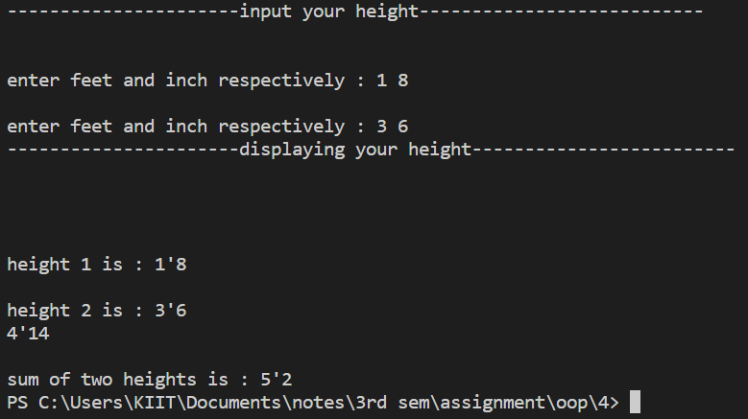
Q.2. Write a C++ program to capitalize the first letter of each word of a given string. Words mustbe separated by only one space.
Output

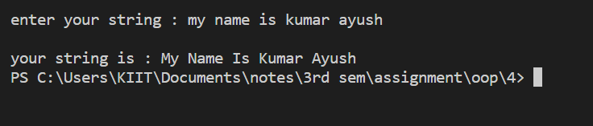
Q.3. Write a C++ program to find the largest word in a given string.

#include <iostream>

using namespace std;
class string {
char str[100];
public :
void input (){
cout<<"\nenter your string : ";
scanf("\n%[^\n]s" , str);
}
void large_word (){

int n=0 , nw=0 , i , j=0 , lw=0;
while(str[n] != '\0'){
if((str[n++] != 32))
nw++;
else{
i = n ;
nw=0;
}
lw = lw>nw?lw:nw;
j = lw>nw?j:i;
}
cout<<endl<<j;
cout<<endl<<"the largest word is : ";
for(int k=j ; k<j+lw ; k++ )
cout<<str[k];

}
}s;
int main(){
s.input();
s.large_word();
return 0;
}

#include <iostream>

using namespace std;
class string {
char str[100];
public :
void input (){
cout<<"\nenter your string : ";
scanf("\n%[^\n]s" , str);
}
void display (){

int n=0;
while(str[n] != '\0'){
if((str[n++] == 32))
str[n] -= 32;
}
str[0] -= 32 ;
cout<<"\nyour string is : "<<str;

}
}s;
int main(){
s.input();
s.display();
return 0;
}

Output

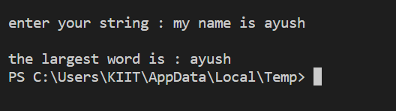
Q.4. Write a C++ program to sort characters (numbers and punctuation symbols are notincluded) in a string.

#include <iostream>

using namespace std;
class string{
char str[100];
public :

void input(){
cout<<"enter your string : ";
cin>>str;
}
void sort_dis(){
int m=0 , n;

while(str[m] != '\0'){
n=0;
while(str[n+1] != '\0'){
if(str[n] > str[n+1]){
char temp = str[n];
str[n] = str[n+1];
str[n+1] = temp;
}
n++;
}
m++;
}
cout<<endl<<"the sorted string is : "<<str;
}
}s;
int main(){
s.input();
s.sort_dis();
return 0;
}

Output

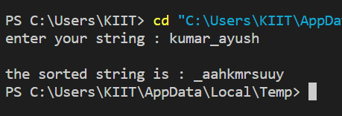
Q.5. Write a C++ program to count all the words in a given string.

#include <iostream>

using namespace std;
class string{
char str[100];
public :

void input(){
cout<<"enter your sentence : ";
scanf("\n%[^\n]s", str);
}
void n_words(){
int n=0 , i=1;
while(str[n] != '\0'){
if(str[n++] == 32)
i++;
}
cout<<"total no. of words : "<<i;
}
}s;
int main(){
s.input();
s.n_words();
return 0;
}

Output

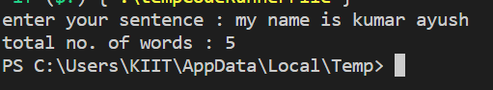
Q.6. Write a C++ program to dynamically allocate an array of 10 elements and print the sum.
#include <iostream>

using namespace std;
class arr{
int n;
public :

int* in(){
cout<<"\n\nenter no. of element : ";
cin>>n;
int *a = new int[n];
cout<<"\nenter "<<n<<" values for your array : ";
for(int i=0 ; i<n ; i++)
cin>>*(a+i);
return a;
}
void sum(int *a){
int l=0;

for(int i=0 ; i<n ; i++)
l += *(a+i);

cout<<endl<<"the sum of array is : "<<l;
}
}s;
int main (){
s.sum(s.in());
return 0;
}

Output

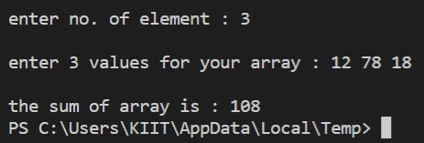
Q. 7. Write a C++ program to calculate the power of any number using recursion.

#include <iostream>

using namespace std;
class power{
int b;
int p;
public :

int in(){
cout<<"enter base and power respectively : ";
cin>>b>>p;
return p;
}
int pow(int p){
static int no = 1;
if(p == 0)
return no;
else{
no *= b;
pow(p-1);
}
}
}s;
int main(){
cout<<"\nthe power is : "<<s.pow(s.in());
return 0;

}

Output

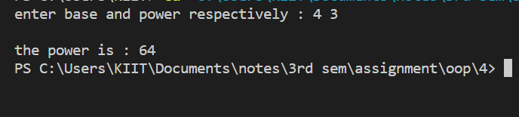
Q. 8. Write a C++ program for binary search using recursion.

#include <iostream>

using namespace std;
int bin(int *a , int l , int r , int mid , int n){

if(*(a+mid) == n)
return (mid);
if(*(a+l) == (*(a+r)))
return -1;
else if(*(a+mid) > n){
r = mid-1;
mid = (l+r)/2;
bin(a , l , r , mid , n);
}
else if(*(a+mid) < n){
l = mid+1;
mid = (l+r)/2;
bin(a , l , r , mid , n);
}
}
int main(){
int *a = new int(10);
cout<<"enter 10 vlaues for your array : ";
for(int i=0 ; i<10 ; i++)
cin>>*(a+i);
for(int i=0 ; i<10 ; i++){
for(int j=0 ; j<10 ; j++){
if((*(a+j)>*(a+j+1)) && (j+1) < 10){
int temp = *(a+j);
*(a+j) = *(a+j+1);
*(a+j+1) = temp;
}
}
}
cout<<endl<<"the sorted array is : ";
for(int i=0 ; i<10 ; i++)
cout<<a[i]<<" ";
int n;
cout<<"\nenter the no. to be searched : ";
cin>>n;
int c = bin(a , 0 , 9 , 9/2 , n);
if(c==-1)
cout<<endl<<n<<" not found in the array";
else
cout<<endl<<n<<" is present at "<<c<<" index";
}

Output

